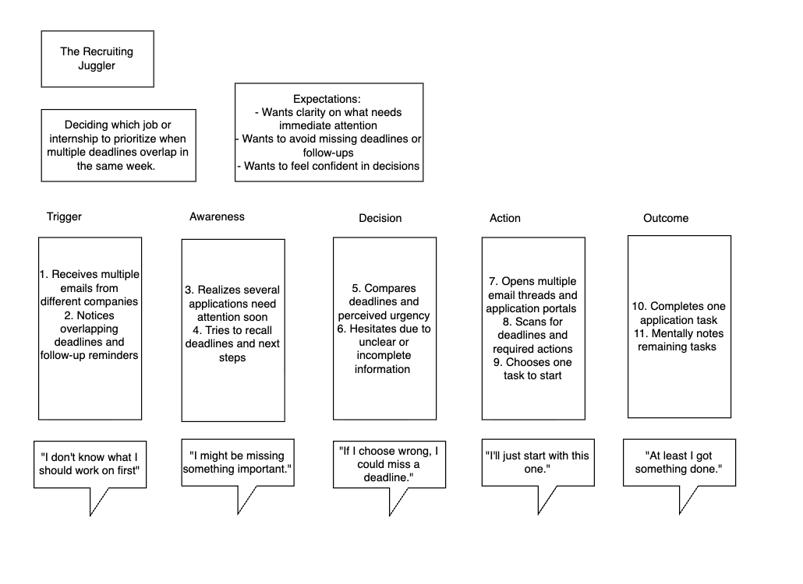
Scenario: deciding which job or internship application to prioritize when multiple deadlines and follow-up requirements overlap in the same week
Problem: the user needs to determine what action to take first across multiple applications without missing deadlines or making the wrong choice
Success: the user feels confident when they chose the right task to work on, knows what comes next, and feels less stressed about missing something important

- Trigger
  - What causes the user to notice the problem right away?
    - Multiple application deadlines or follow-up reminders appear at the same time
    - New emails arrive from different companies within a short period
  - What makes this moment urgent?
    - Deadlines are approaching
    - The user fears missing a required action
  - What is the user thinking or feeling?
    - “I don’t know what to work on first.”
    - Anxiety and pressure due to limited time
- Awareness
  - What does the user realize they need?
    - A clear understanding of application status and urgency
  - What information do they wish they had?
    - Which applications require immediate action
    - What happens if they delay one task over another
  - What feels unclear or confusing?
    - How to prioritize across different timelines
    - Which deadlines matter most right now
  - Emotions
    - Overwhelmed
    - Uncertain
    - Slight panic
- Decision
  - Which decision are they trying to make?
    - Which application to work on first
  - What criteria matter most?
    - Deadline proximity
    - Risk of missing an opportunity
    - Time required to complete the task
  - What causes hesitation?
    - Fear of choosing wrong
    - Incomplete or unclear information
  - What shortcut do they take when rushed?
    - Working on the easiest or most familiar task first
    - Responding to the most recent email
- Action
  - What actions do they take?
    - Open multiple email threads and application portals
    - Scan for deadlines and instructions
    - Jot notes or mentally track what needs attention
  - What do they use today?
    - Email inbox
    - Company portals
    - Personal notes or memory
  - Where do they get stuck?
    - Switching between platforms
    - Losing track of what’s already reviewed
  - What costs time or attention?
    - Re-reading emails
    - Searching for missing information
- Outcome
  - What happens right after the action?
    - The user picks one task to work on
  - How do they feel?
    - Temporary relief
    - Lingering uncertainty about other applications
  - Did the action reduce the original pain?
    - Partially - stress decreases slightly but doesn’t disappear
  - What new problem appears?
    - Worry about what still hasn’t been addressed
    - The cycle may repeat the next day

